Budget for Treatment Room

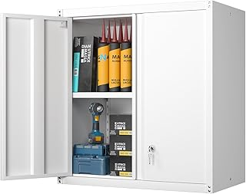

Wall Cabinet to store supplies $88.00 X 2= $176
https://a.co/d/8TUEqKD

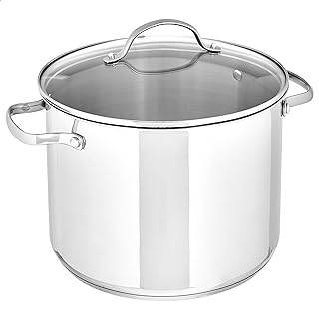
Pot for hot water $28.34
https://a.co/d/2MmNo4p

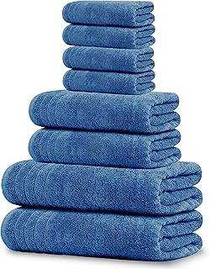

Set of Cotton Towel $33.95
https://a.co/d/iLwzGqK

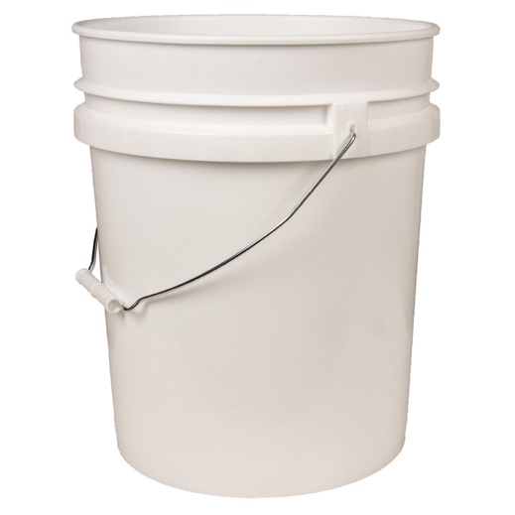
5 galloon bucket $7.32
https://www.azurestandard.com/shop/product/household-family/storage/buckets-pails-lids/buckets-pails/empty-5-gallon-plastic-pailbucket-without-lid/7838?package=PS092
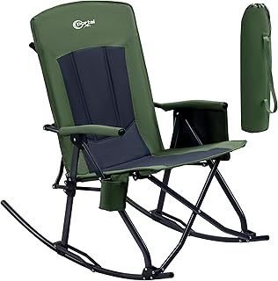
Chair for Hydrotherapy (migraine) $89.99
https://a.co/d/gIFcm1p

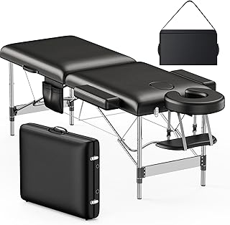
Massage Table $99.99
https://a.co/d/9vYasYO

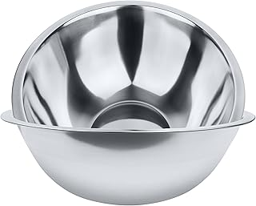
2, 5 Qt Stainless Steel Bowls $17.95
https://a.co/d/4QUq7Nx

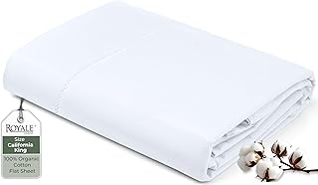

2 Cotton Sheets $44
https://a.co/d/gxd6yNJ

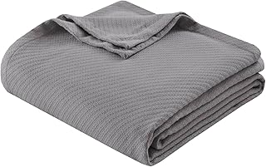
Cotton Blanket $37.99
https://a.co/d/byRSsSp

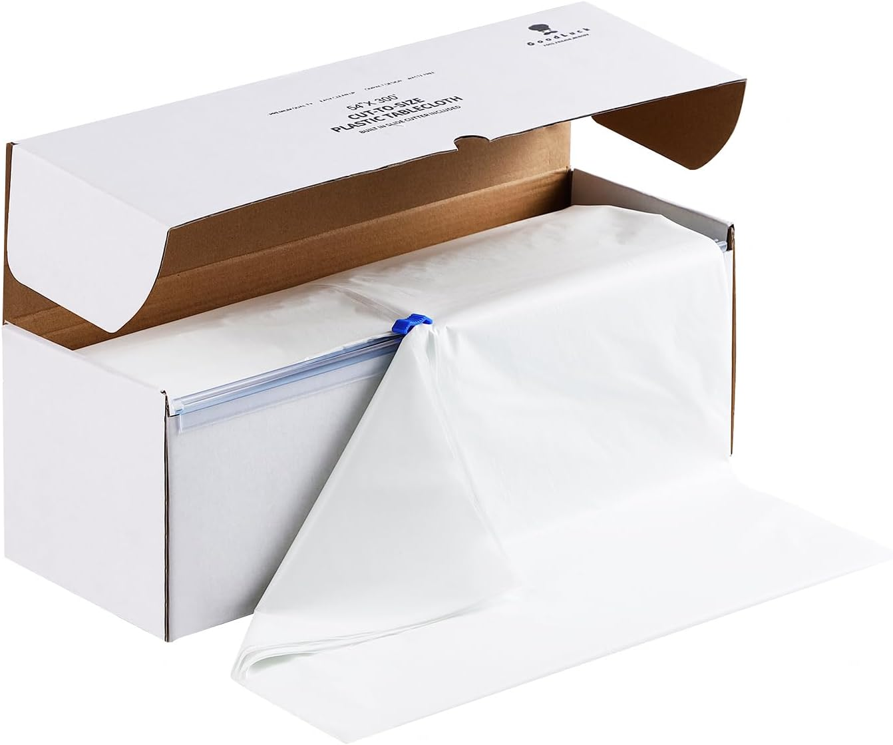
Plastic for Sauna $27.99
https://a.co/d/eV0WkzZ

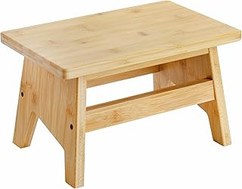
Wooden Stool $24.99
https://a.co/d/0jKpYf7

bowls for poultices
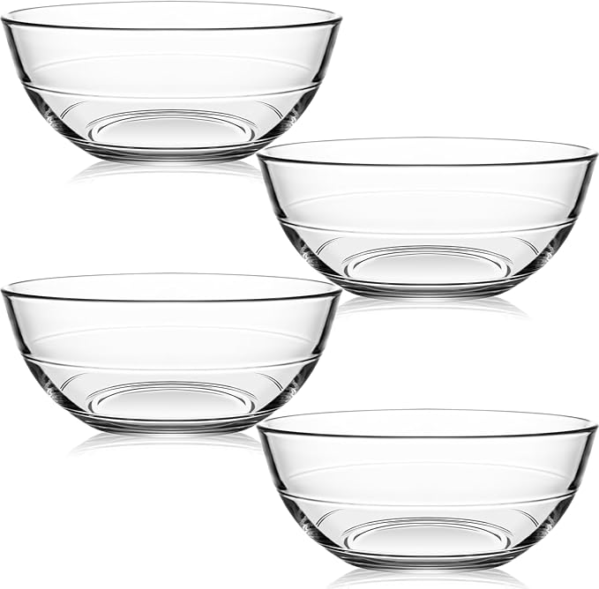

Glass Bowls for Poultices $24.99
https://a.co/d/53ig74s

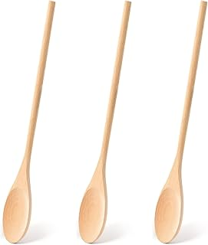
Wooden spoons $6.99
https://a.co/d/1wufZLX

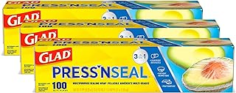
To wrap $14.97
https://a.co/d/5LPkfFI

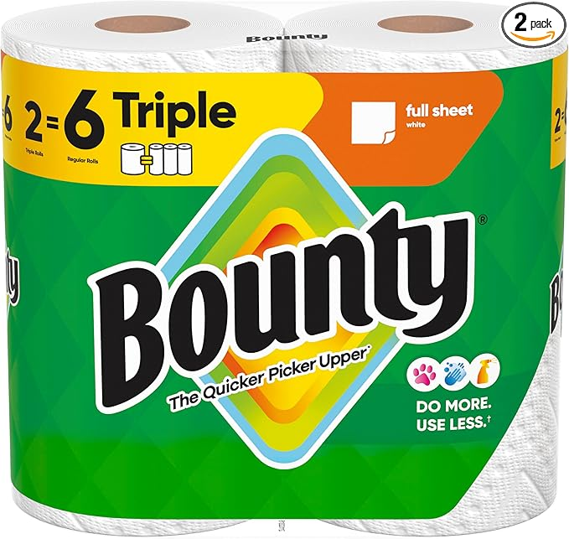
Paper Towel $8.78
https://a.co/d/esh5JyP

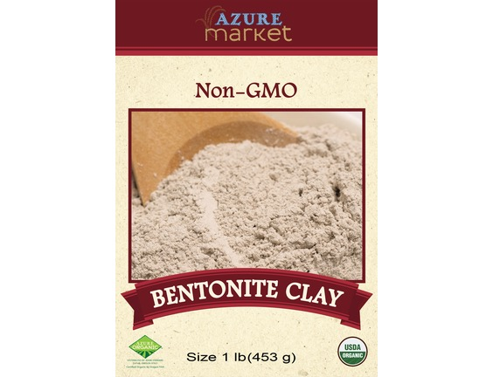

Bentonite Clay 1 lb. $6.52
https://www.azurestandard.com/shop/product/health-beauty/healing-first-aid/clay/bentonite/bentonite-clay/37512?package=HB2390

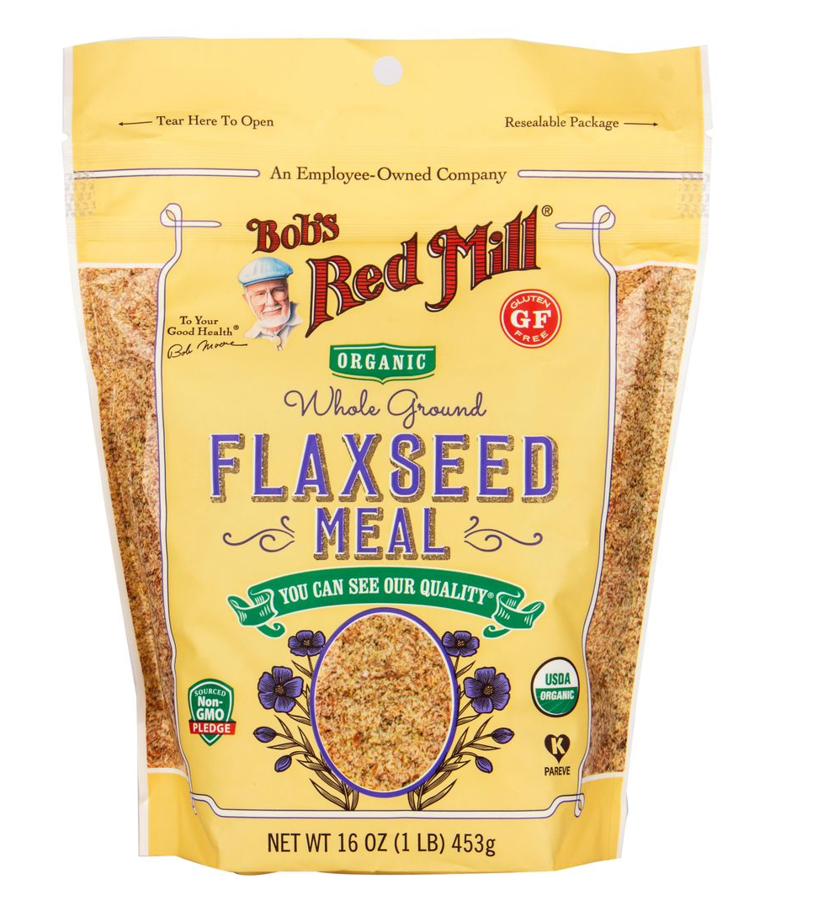
Flaxseed Meal 1 Lb. $5.13
https://www.azurestandard.com/shop/product/food/flour/nut-seed-meals/flax/flaxseed-meal-organic/8021?package=FL203

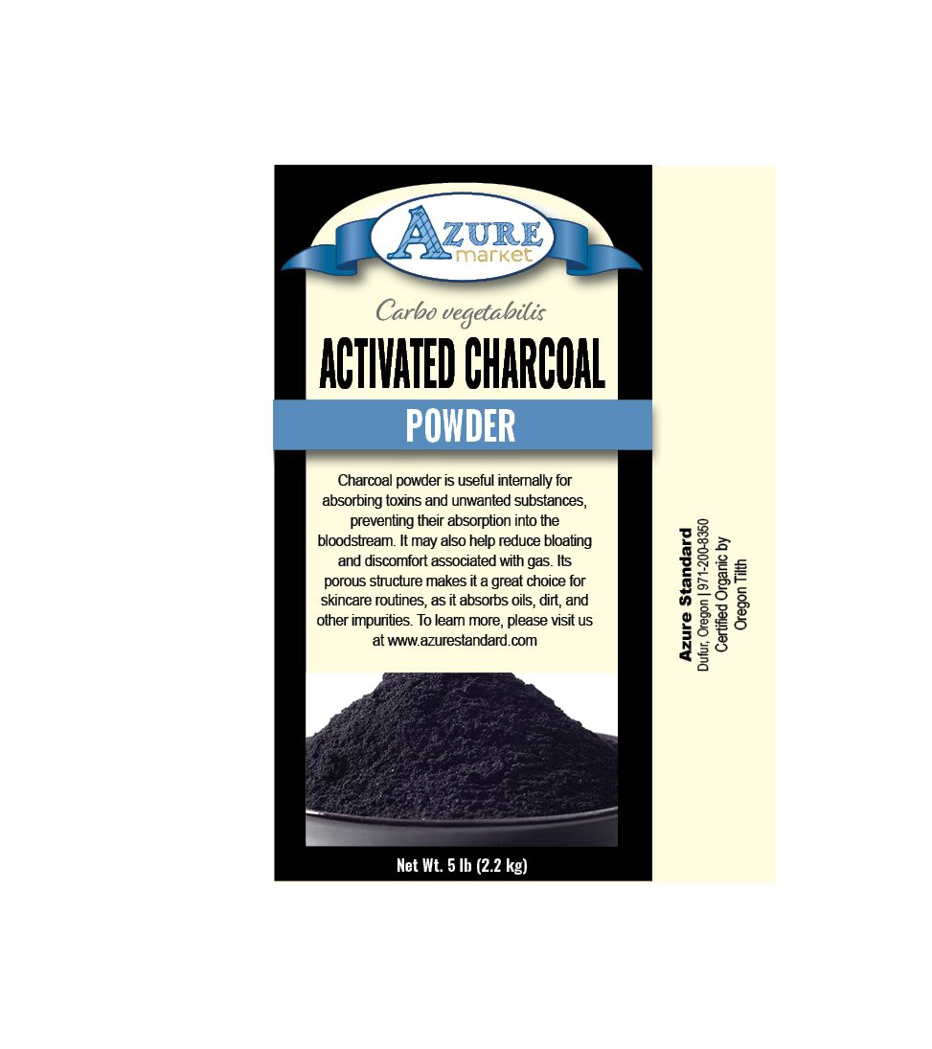
Activated charcoal 1 Lb. $6.26
https://www.azurestandard.com/shop/product/nutritional-supplements/herbs/single/charcoal-activated/powder/activated-charcoal-powder/7074?package=HS386

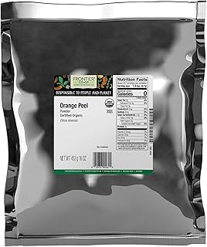

Orange Peel Powder, organic, 1 lb. $17.95
https://a.co/d/80ANyHY

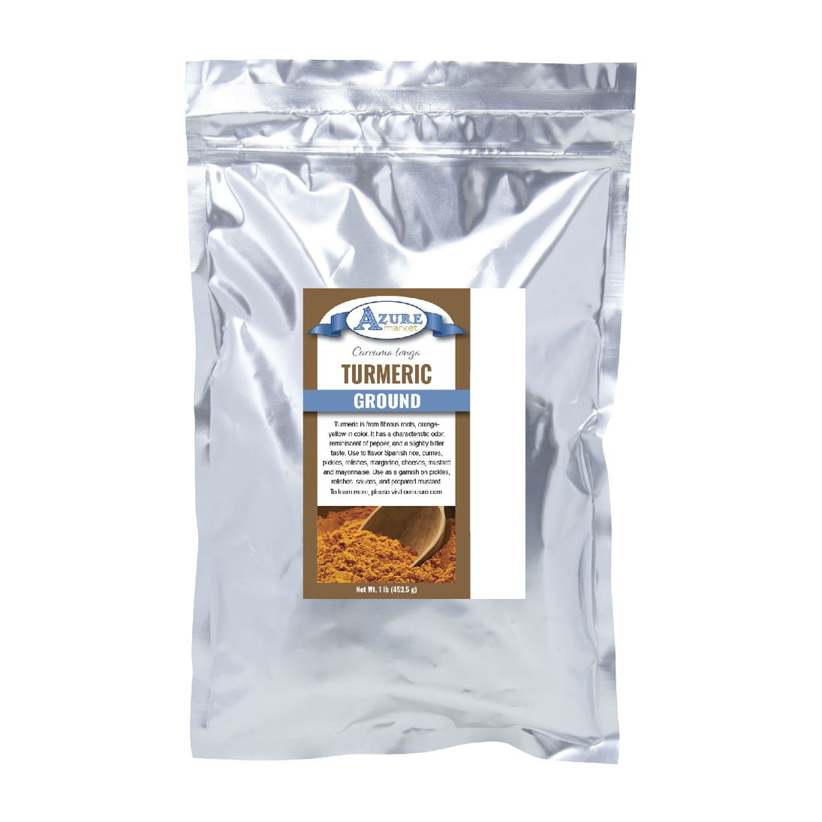
Turmeric Powder, organic, 1 Lb. $6.59
https://www.azurestandard.com/shop/product/food/spices-seasonings/spices/turmeric/dried/turmeric-ground/11402?package=HS222

total cost: $686.69

Approximately Budget to start a treatment room: $700

